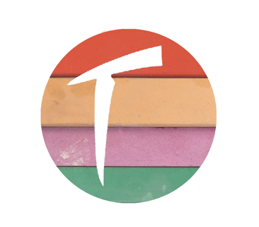
TOGIDAI
Sharpening Station
Services Form
* Mandatory fields
* Name
* Address
* Phone number
* e-mail

Knife profile (Chef’s, Paring, Yanagiba, etc…) | Quantity | Details of service (sharpening only, rust removal, blade polishing, tip repair, etc…)
Other Items (sleeve, knife bag, towels…)
Make sure all knives and tools are wrapped individually and placed safely in a box. If loose inside, please fill the gaps in the
box with newspaper to minimise chances of damage.
Address:
33 Queens Road
E11 1BA
London - UK
We will send your items back once payment for service and shipping is confirmed.
‘I agree that I am fully responsible for any items that may get damaged or lost by the courier service.’

* Date ____/____/____ * Signed __________________________

